## **Assignment for Week 7 readings:** (due Tues 30 November)

Giorgia Spreafico, Neri Niccolo Dei, Gianluca Manduca, Syeda Zaidi, Radan Pathan

[Contattaci: #week7 sul Slack](https://topicsinmulti-b5g1638.slack.com/archives/C02N2KD5HMW)

Goal: Compute limit surfaces for non-frictional grasping using spines and gecko-inspired adhesives, and check whether applied loads can be sustained by a grasp.

* [Link to presentation (Google slides)](https://docs.google.com/presentation/d/1db5VDkxd8cO3HsxclGBs-Xx5LLzA9z99r3o7ELjAbPo/edit?usp=sharing)

### Q1. Grasping with spines

A small flying robot with spines is grasping a block. We approximate the gripper with two fingers, each equipped with a few spines, and having stiffness matrices for (x,y,z) forces applied at the contacts. (We assume somebody else has generated these from structural and joint stiffness.) The fingertips have local coordinate frames with z inward, as shown.

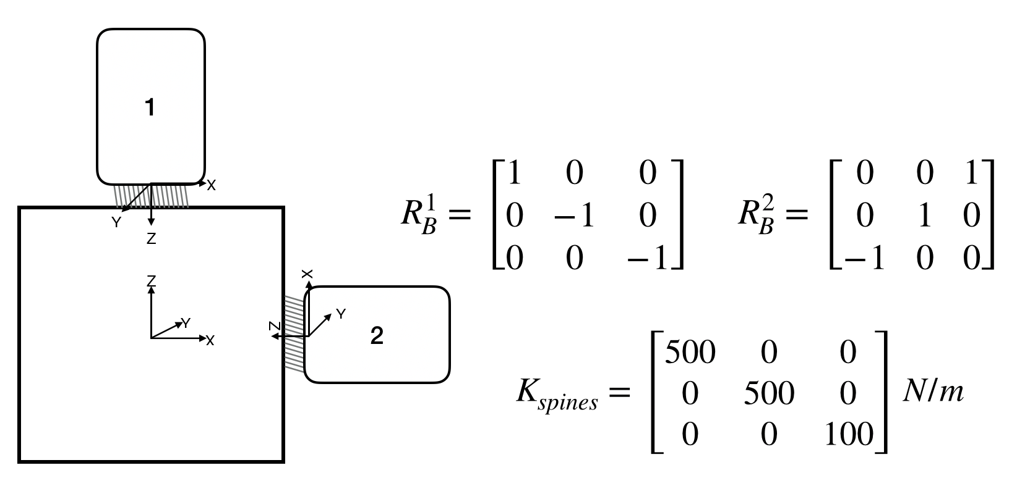

We assume moments are not transmitted by the small collections of spines at each fingertip -- in part because the spines are on compliant suspensions.

We can use grasp stiffness (Week3) to obtain the change in force at each finger in response to an external perturbation on the object. The process, encoded in **Spine-Grasp-Stiffness.py**, is as follows:

1. An external wrench, applied to the object, produces a displacement (twist) db. In the present case, we assume it is a small translation in the (x,z) plane: [dx,0,dy,0,0,0].
2. The corresponding fingertip displacements are dx_i = [H]*[pbJ_i]*db where [H] is the filtering matrix for small contacts (transmits displacements but not rotations) that we have seen before and [pbJ_i] is the cartesian transformation matrix from the object to finger frame i.
3. The corresponding changes in finger forces are df_i = [Kf_i]*dx_i at each fingertip.
4. We add these perturbation forces to any initial bias (e.g. grasp) forces: f_i = fbias + df_i
5. The fingertips can have an initial bias force, [fbias,0,fbias], in newtons in local fingertip coordinates. Note that to be in the null space this bias force is equal and opposite on both fingers and the X and Z components are equal.

**Let’s try some realistic numbers:**

* Assume that the contacts have a lateral stiffness of ksl = 500N/m in x and y directions and a normal stiffness of ksn = 100N/m in the z direction.
* At each contact there is a spine *limit surface* such that any force vector inside this limit surface can be supported. If the vector goes outside the limit surface it will either slip or separate. The vertices of a simplified spine limit surface are as follows (values in newtons)

[0,0,0];[0,-1,0]; [0,1,0]; [-1,1,2]; [-1,-1,2];[-1,0,2];[3,-1,2]; [3,1,2]; [3,-1,-0.75]; [3,1,-0.75]; [3,0,-0.25]; [3,0,2]

The result should look as below. Unlike friction cones or pyramids, it is not convex.

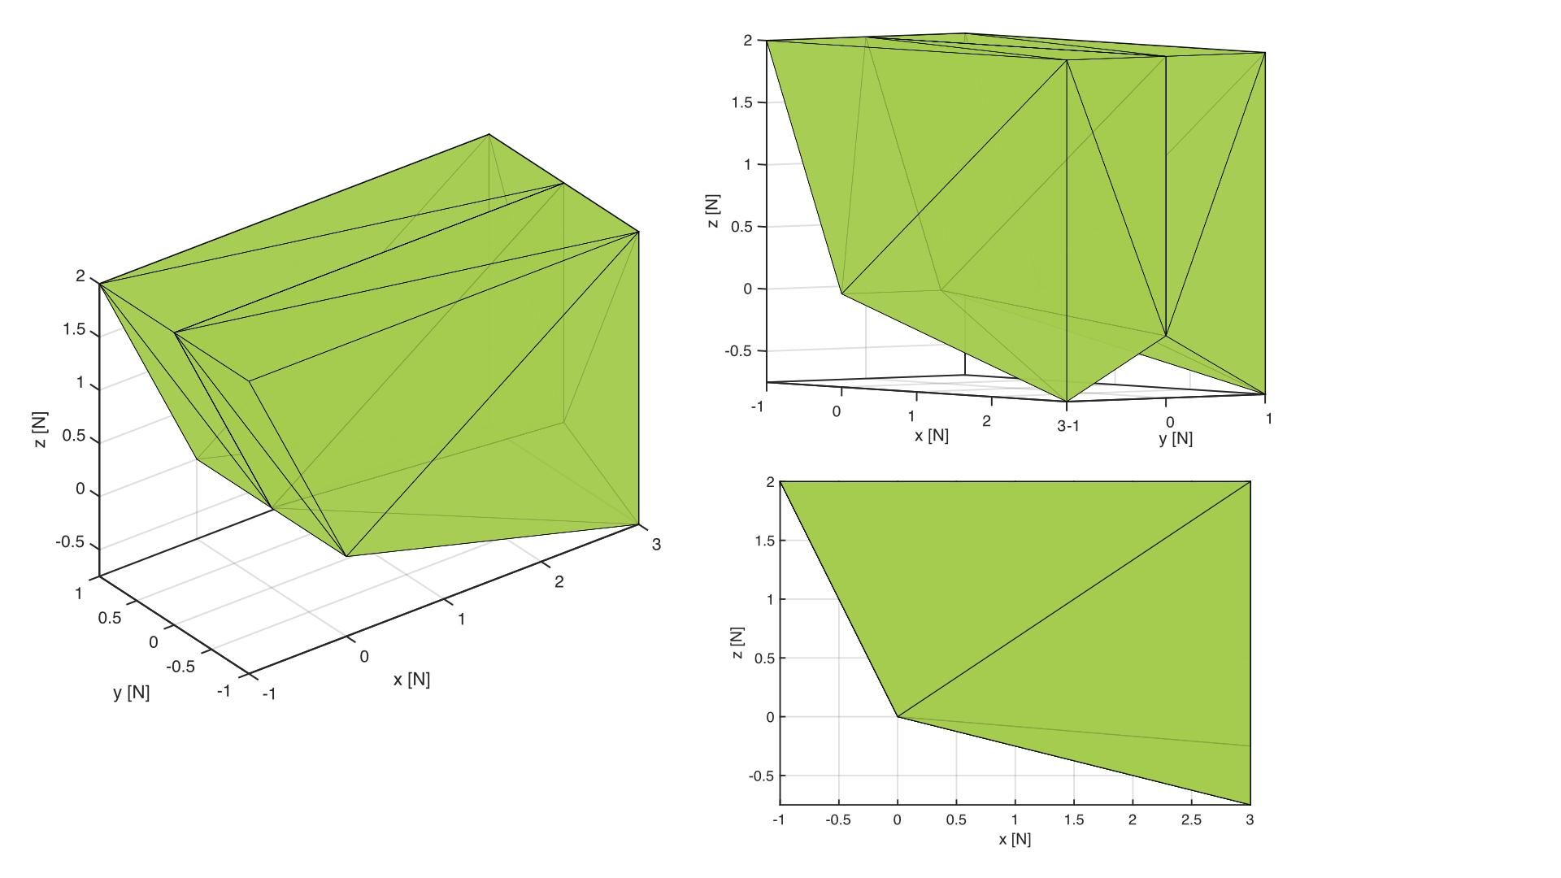

Testing for points inside a non-convex polyhedron often involves decomposing into convex polyhedrons and testing those in sequence. There are a couple of ways to do the decomposition (hierarchical or not). Note that if a point does not fall inside the convex hull of a polyhedron then it will certainly fail for any decomposition as well.

The script **Vector-in-ConvexHull.py** gives an example of constructing the convex hull for our limit surface above and testing whether a vector falls inside it. It also plots the result.

#### Q1.1

Suppose that a disturbance moves the grasped object by db = [-0.002, 0, -0.002] m. Given the stiffness values above, are the resulting force vectors inside the limit surfaces of the fingertips?

#### Q1.2

Find a value for fbias that does a good job of putting the total fingertip forces near the centers of their respective limit surfaces for the same db as above. Also, make sure that your solution for fbias still works if there is no displacement (db = [0,0,0]). Given the constraints on the X and Z components, you can’t get both fingers exactly at the centers of their limit surfaces.

*Tip: If you want to use MATLAB it has useful functions like alphaShapes and inShape to help you with this. However it may be easiest to just add to the python scripts provided.*

### Q2. Grasping with adhesives

Adhesives are sensitive to uneven loads. One way to increase their performance for large areas is to employ load-sharing, so that every adhesive unit experiences the same stress. With the load sharing in Jiang, et al., two-tile units in an array of tiles all have the same normal and tangential force. This characteristic simplifies the computation of the overall limit surface for an entire gripper -- we don’t need to build a stiffness matrix or otherwise deal with static indeterminacy.

As an example, consider an array of four two-tile gripping units below. The gripper shares a load among units using a pulley and tendon differential (as in Jiang et al.). The limit surfaces for the two-tile units are identical. When the limit surface of the two-tile unit is given, we want to:

* Compute the limit surface of the entire gripper (in wrench space) given the limit surface for a single two-tile unit.
* Use the limit surface to find the maximum external wrench magnitude for a given direction.

The image below shows a simplified example of the planar part of the space gripper from Jiang. et al. It consists of four two-tile gripping units. The coordinates of the centroids of each two-tile unit are shown in the (X,Y,0) plane.

The graphs below show the limit surface of a two-tile gripping unit in force space (Fx,Fy,Fz).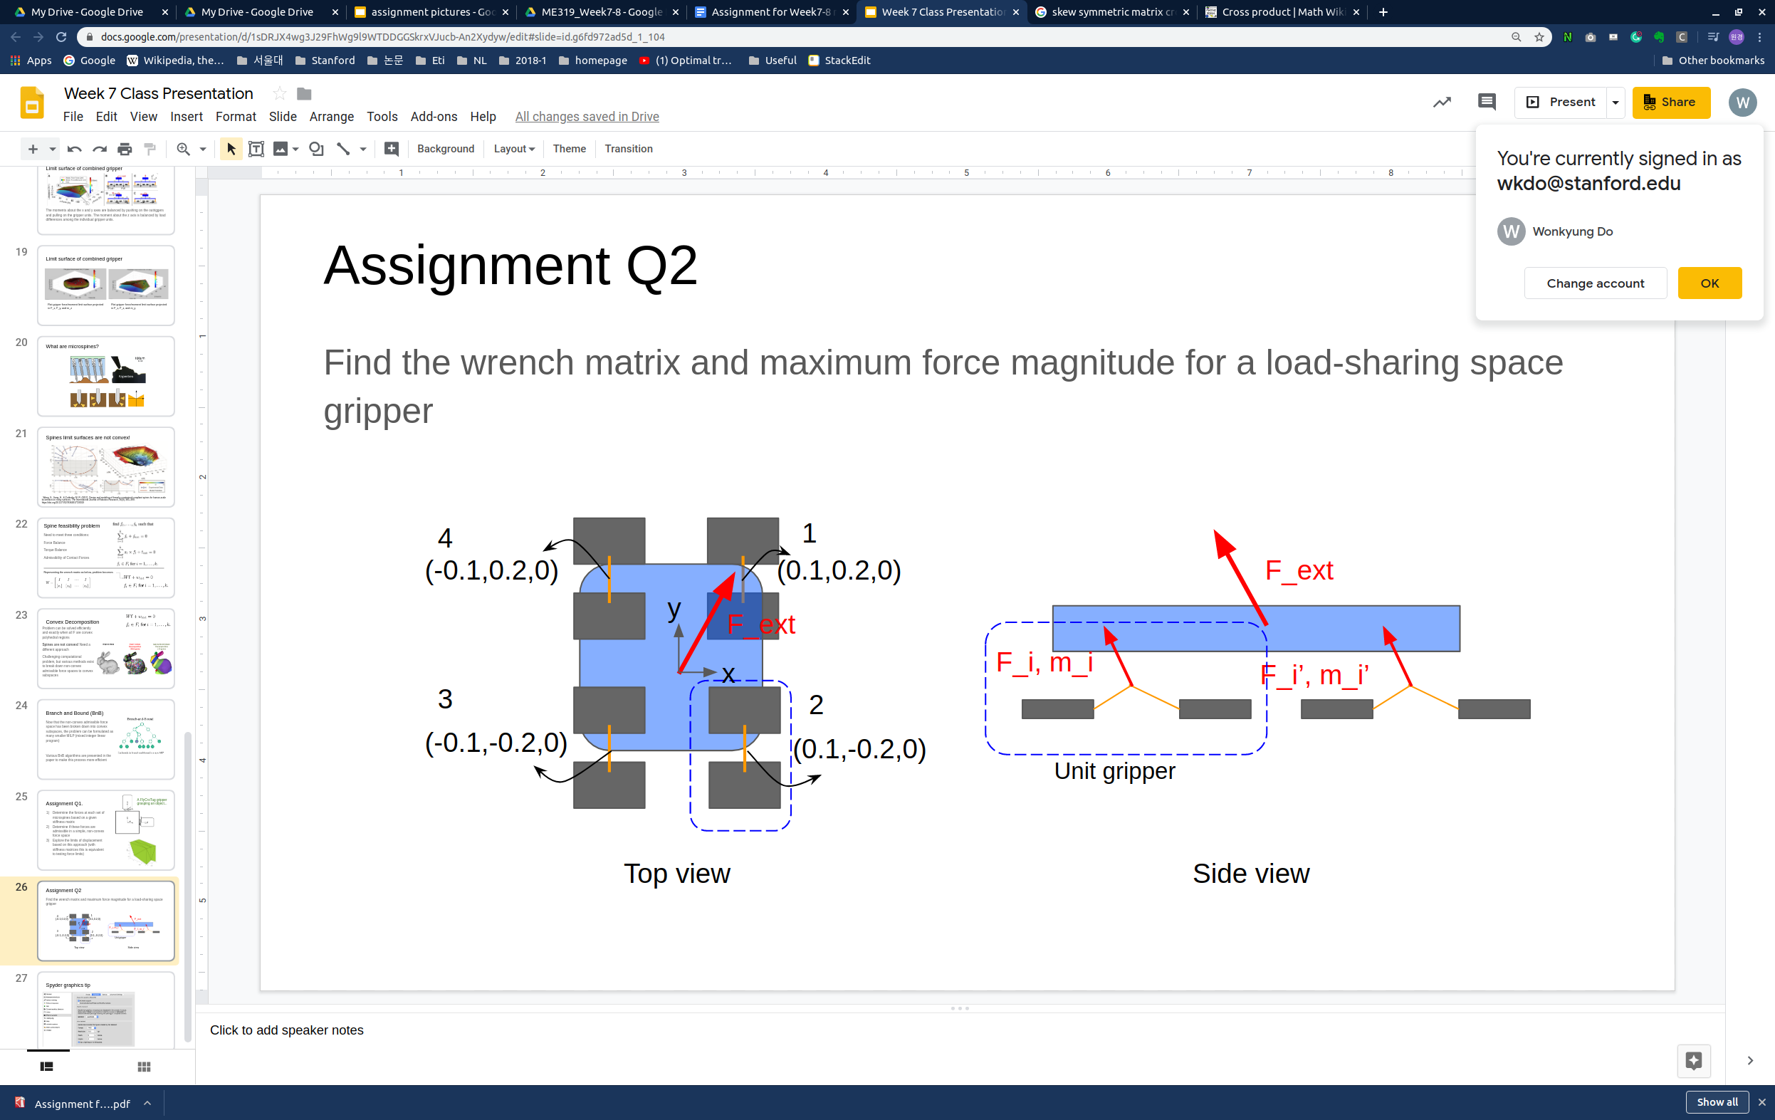

3D views:

|  |  |
| --- | --- |

c

#### Q2.1

An external force Fext = (Fx, Fy, Fz) has been applied to the space gripper at its centroid. Compute the corresponding wrench of each unit gripper 1, 2, 3, and 4. You can assume the local and global frames are aligned.

#### Q2.2

If we ignore bending moments about (X,Y) and assume there is no twisting moment about the Z-axis, we can compute a three-dimensional limit surface of the system, given the diamond-shaped limit surfaces for the two-tile units. Plot this shape (include a figure printout).

#### Q2.3

Using the overall limit surface from 2.2, what is the maximum force magnitude that the space gripper can hold if the force direction is given as [7, 7, -5] in the (x,y,z) directions?